

**UIT University**

**Department of Engineering Technology**

**Course Code: SET-211/CET-224**

**Database System/Database Application**

**Fall 2024**

**Assignment 2**

**Deadline (10 Dec 2024)**

**Case Study: E-Commerce Product Management System**

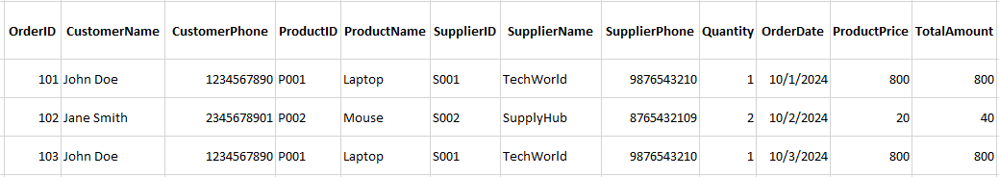**A small e-commerce company needs a database to manage product information, suppliers, and orders. Below is a sample unnormalized table provided by the company:**

**Problems in the current table:**

* Redundancy in storing supplier and customer details.
* Difficulty in updating supplier or product details without anomalies.
* No clear functional dependencies identified.

**Tasks:**

1. **Identify Functional Dependencies**

Analyze the given table to determine the functional dependencies (FDs) between attributes. Identify partial dependency, transitive dependency and full depedency

1. **Convert to First Normal Form (1NF)**

Remove multivalued attributes and ensure each column contains atomic values.

1. **Convert to Second Normal Form (2NF)**

Identify and eliminate partial dependencies by decomposing the table into smaller tables.

1. **Convert to Third Normal Form (3NF)**

Remove transitive dependencies by further decomposing the tables.

**Submitted Guideline:**

Submit in submit in handwritten form.